**Bisinav.net Live Training and Exam Site**

**Five in Fives (a type of exam where you can do 5 questions in 5 minutes), Live Essays (an exam system where you can take the exam online or offline, and continue when connected in case of an internet interruption), E-journals (where you can read e-magazines and e-books). pages), Videos (pages that have not been put into production but have been completed, where people can watch lecture videos) is an education-oriented project. All mobile compatible.**

Mainpage

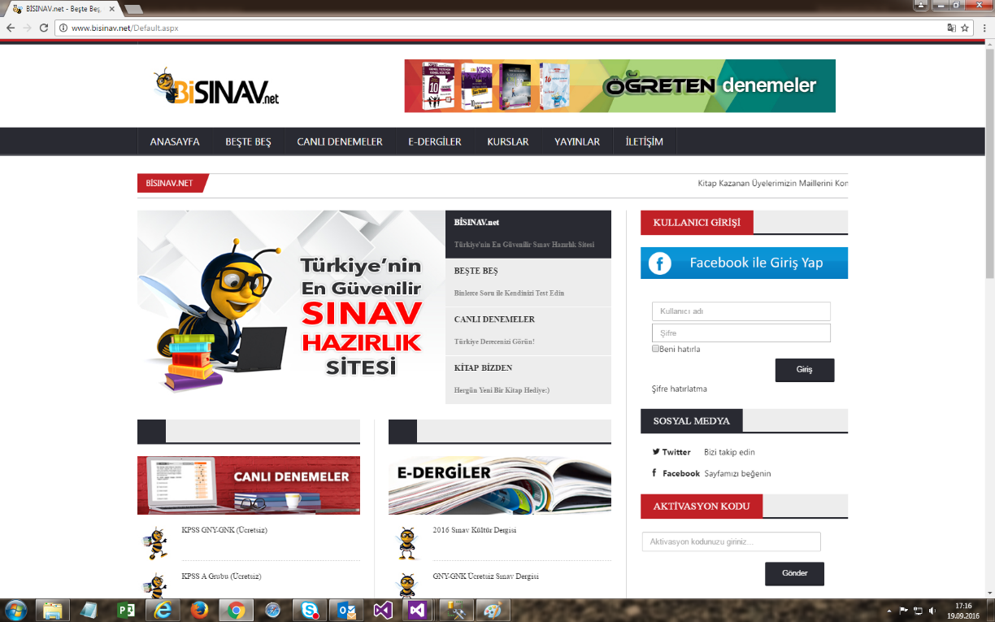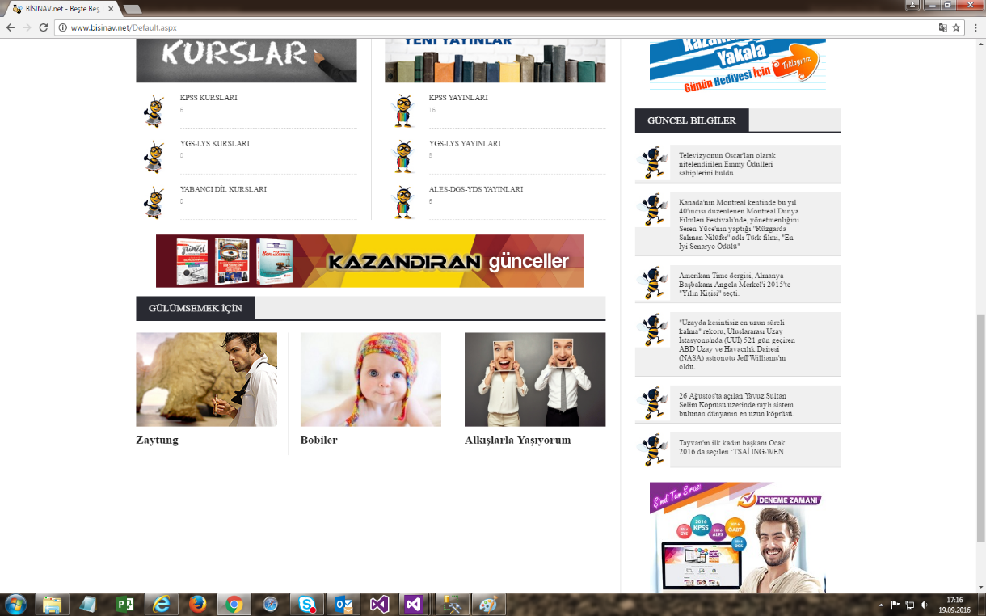

Mobile menus

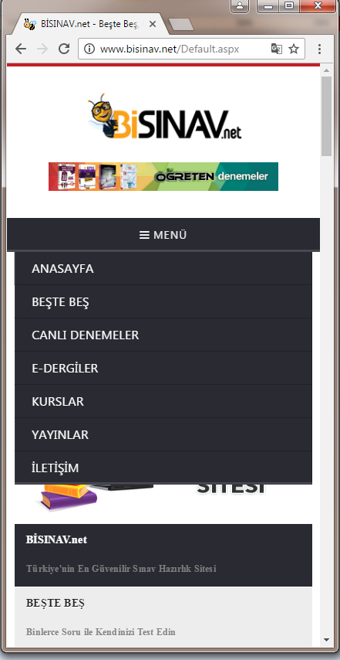

Five in Fives page 

Live Trial page 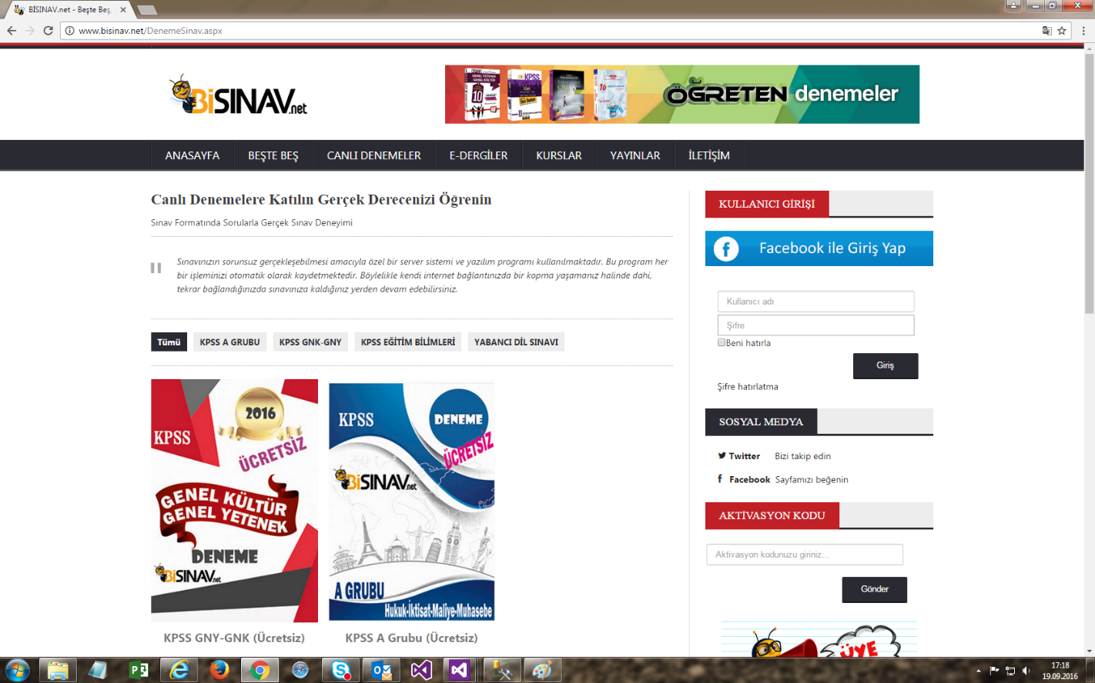

E-journals and E-books pages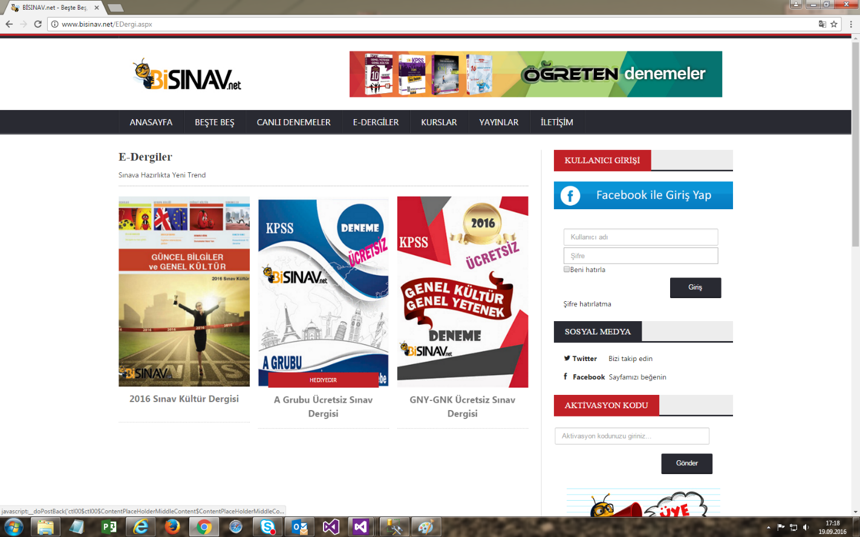

Information pages 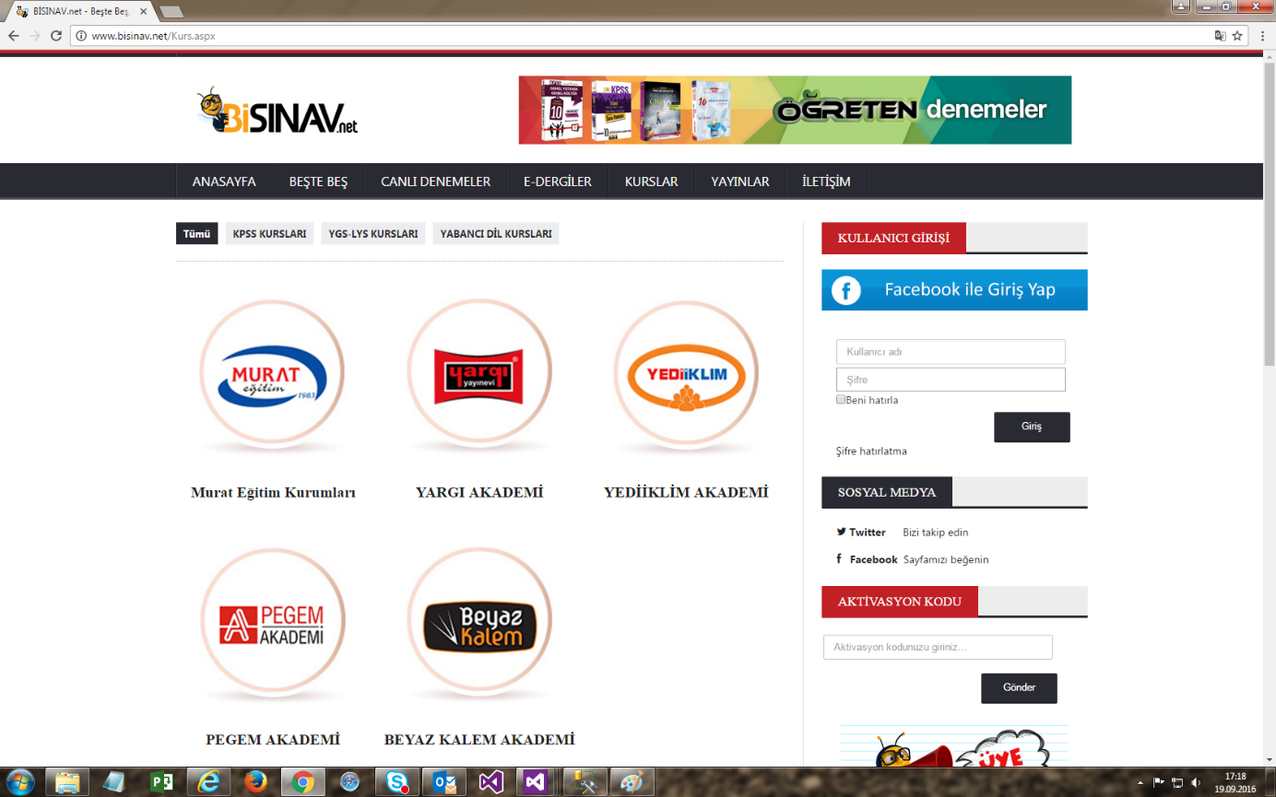

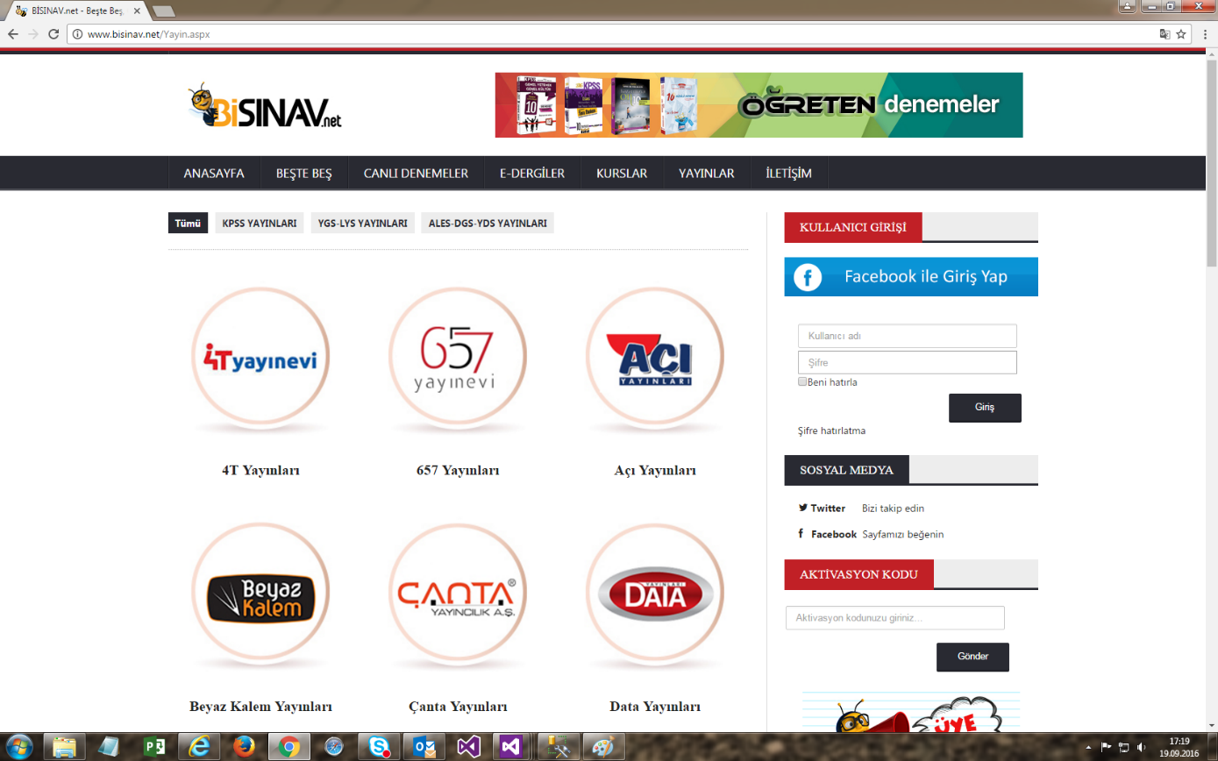

Contact page 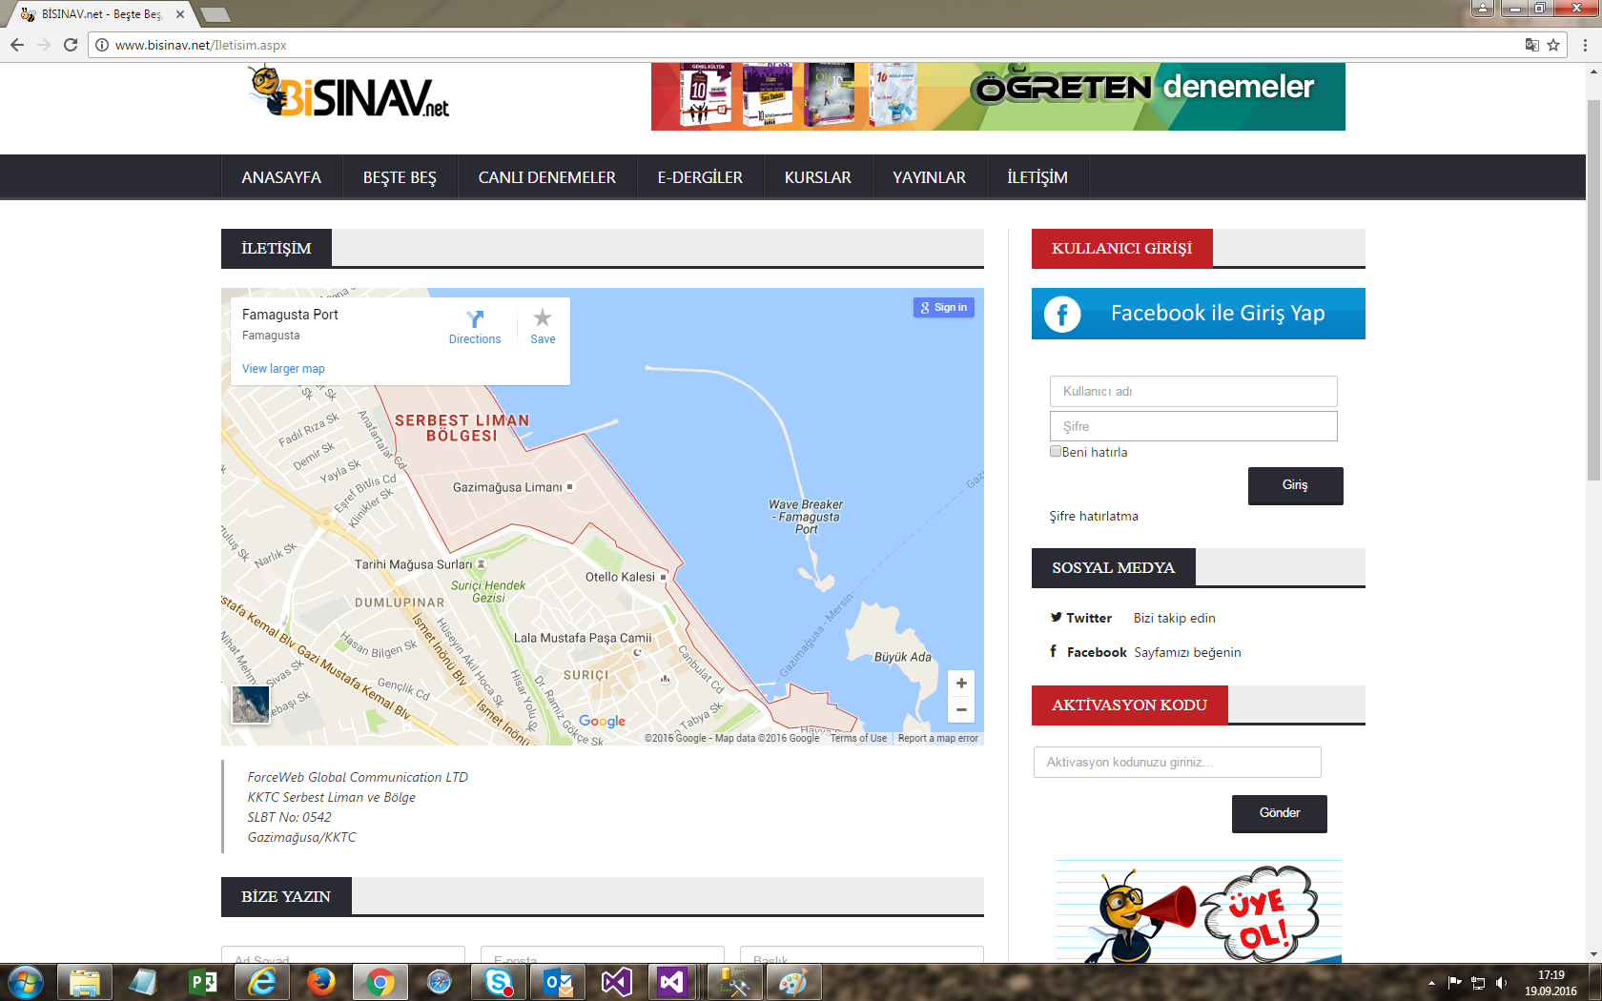

E-journal and E-book reading page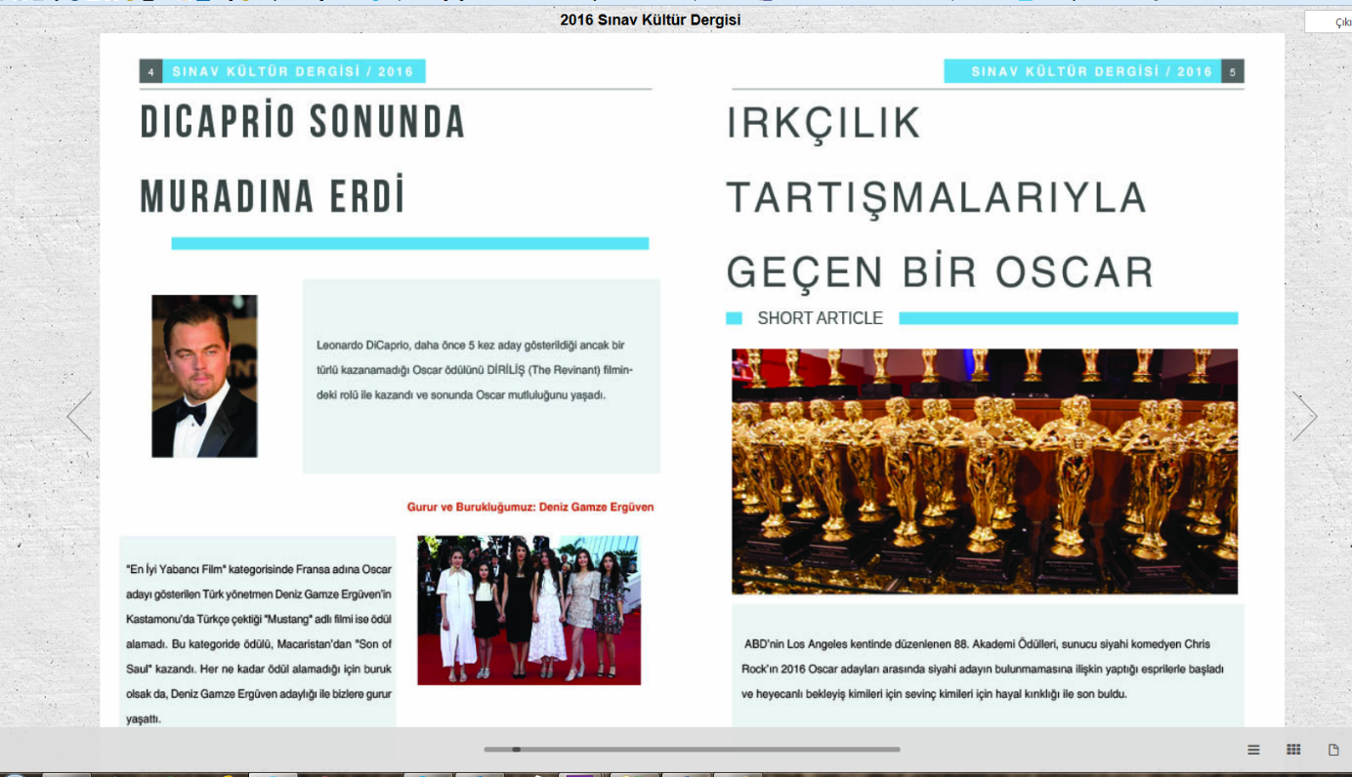

Exam entrance welcome page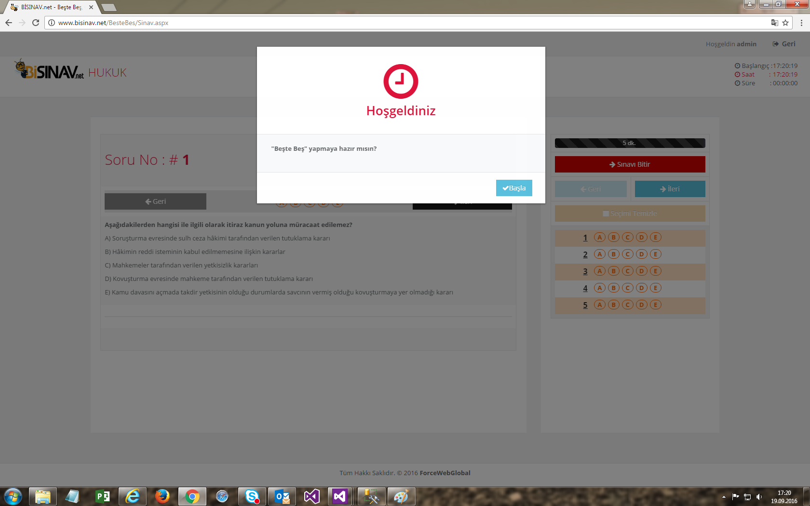

Exam page, where question solutions are made by marking method from optical forms. The remaining time can be followed from the bar on the right. 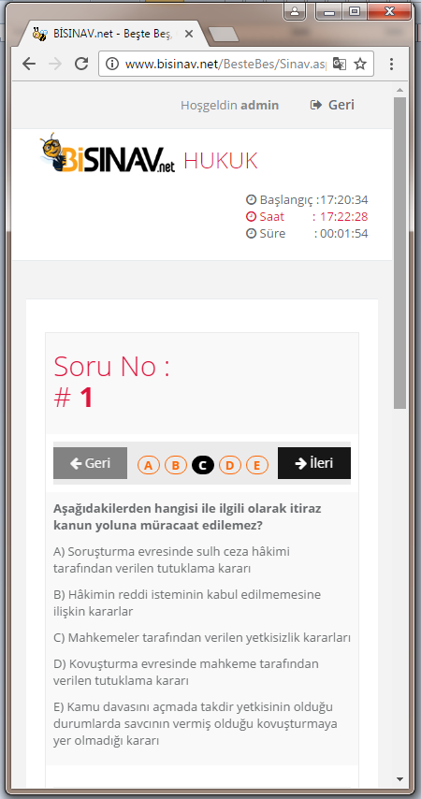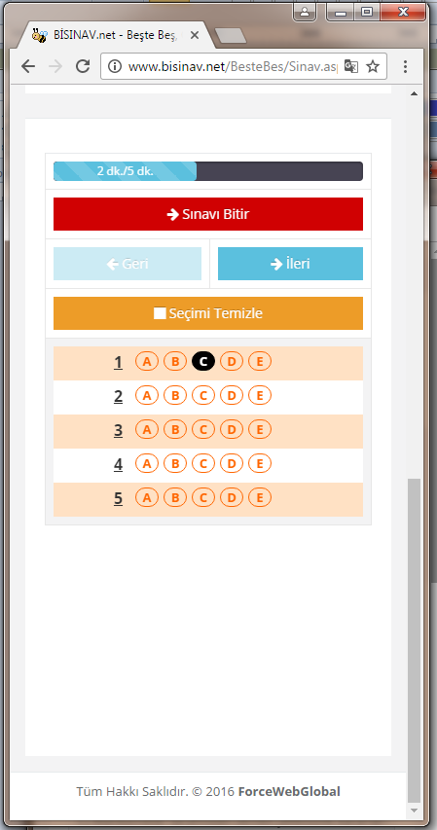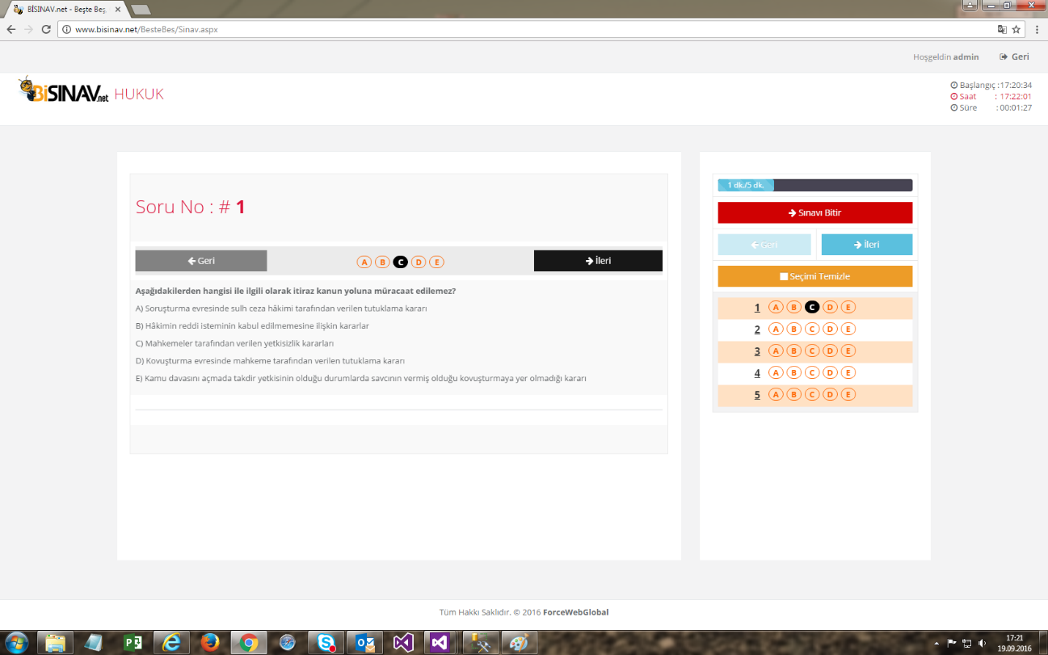

Mobile exam pages

At the top right, information about the exam is given. 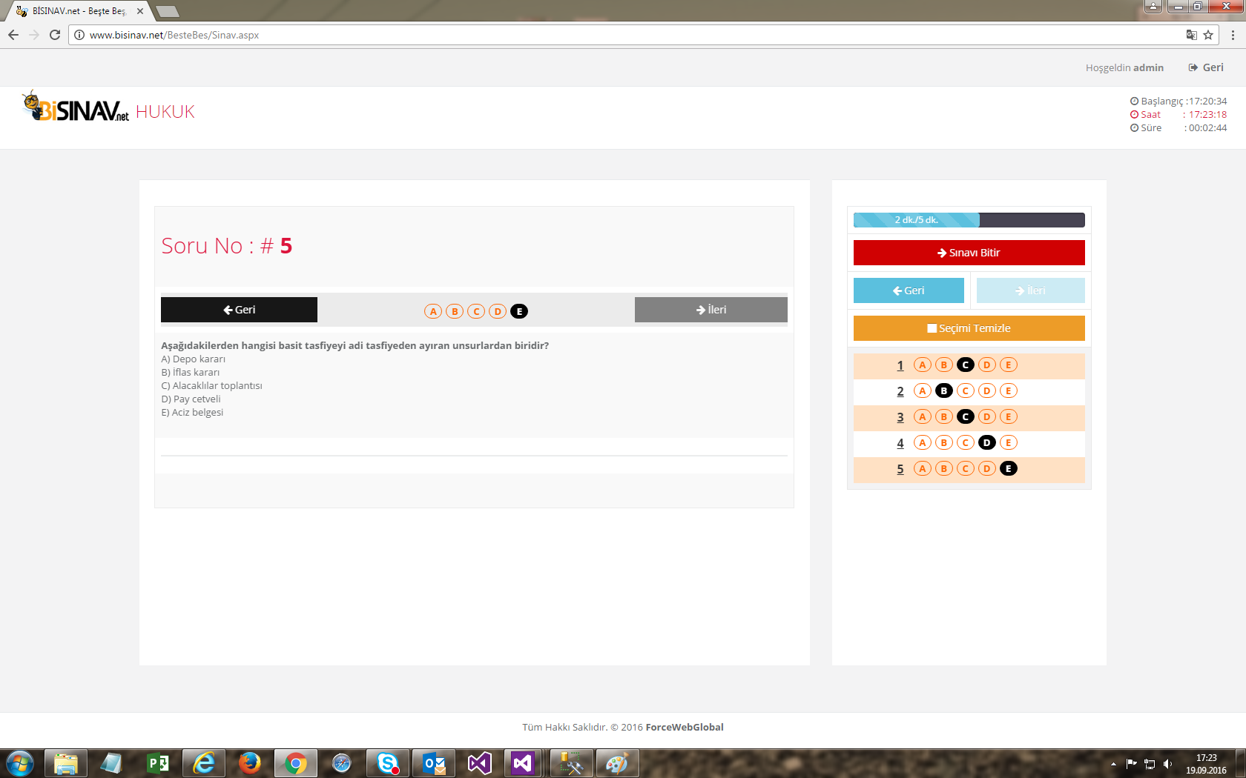

When the exam is finished, the results are shown. If it is a member, the save button appears so that he can watch his statistics. If he wants to see what he has done and the answer explanations about the questions, he presses the Review button. If he/she wants a new exam, he/she can start it again with new random questions (random questions are only available in the Five in Fives section. He draws 5 questions from the question pool. There are no random questions in live trials).

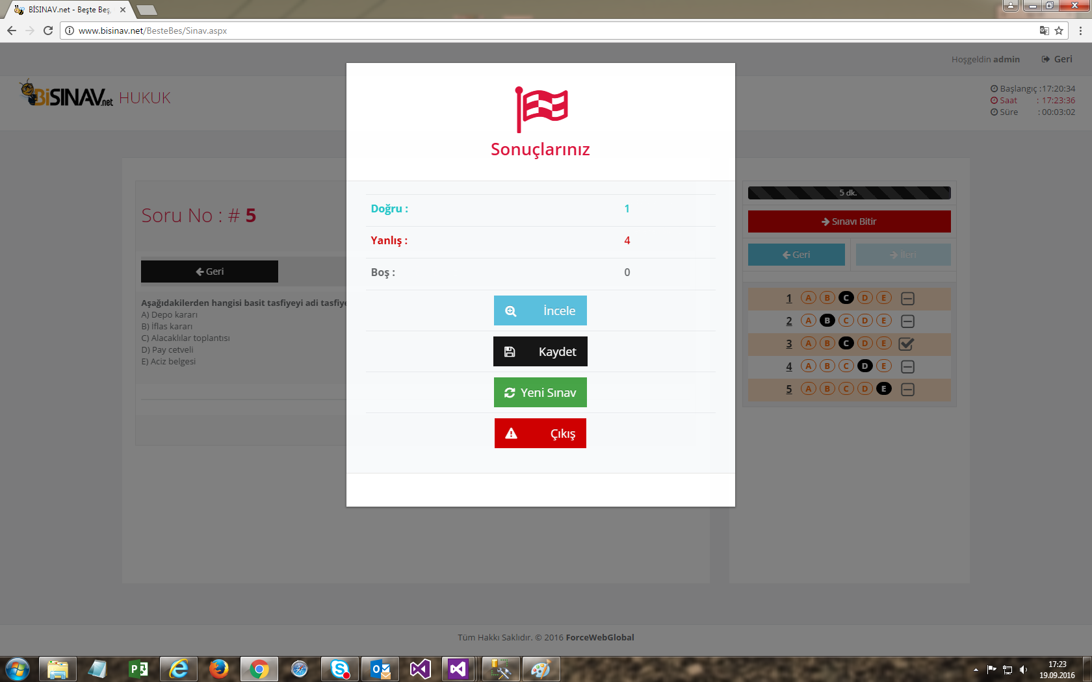

User account information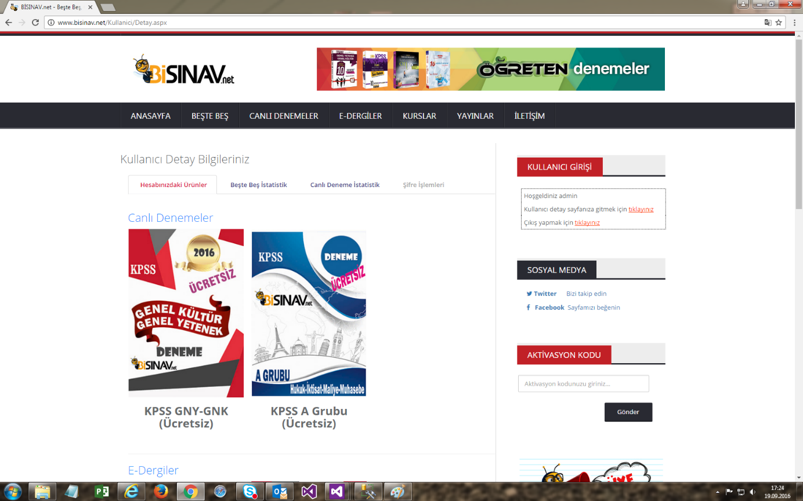

User statistics 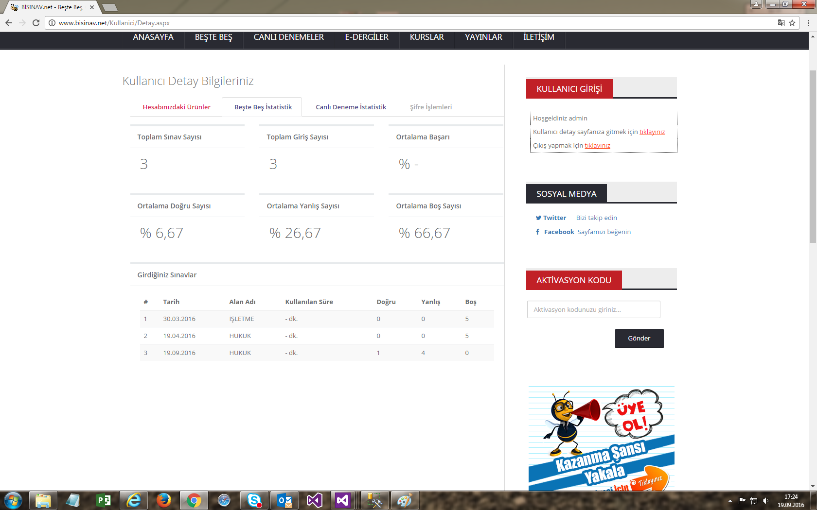

Questions with images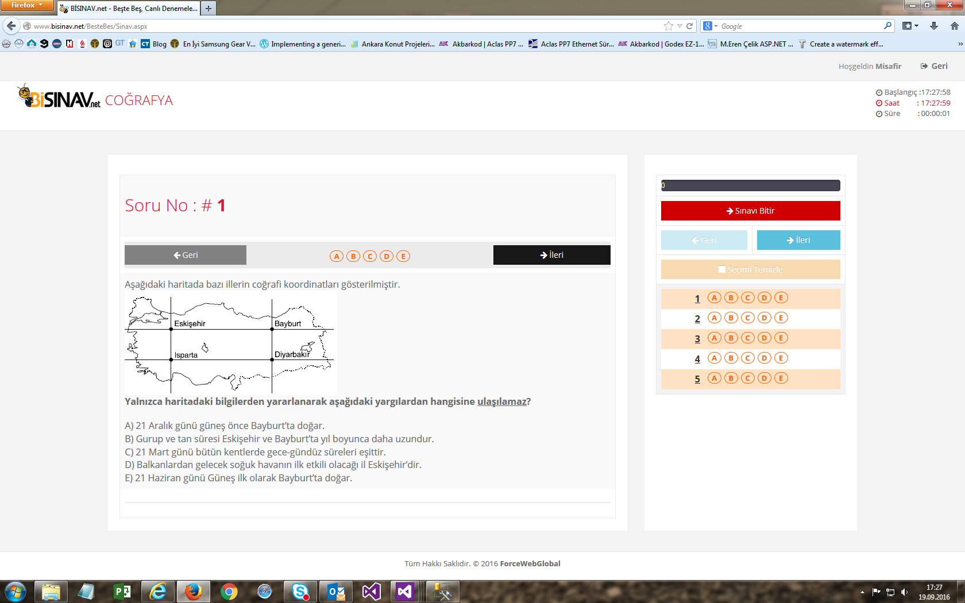

Videos page

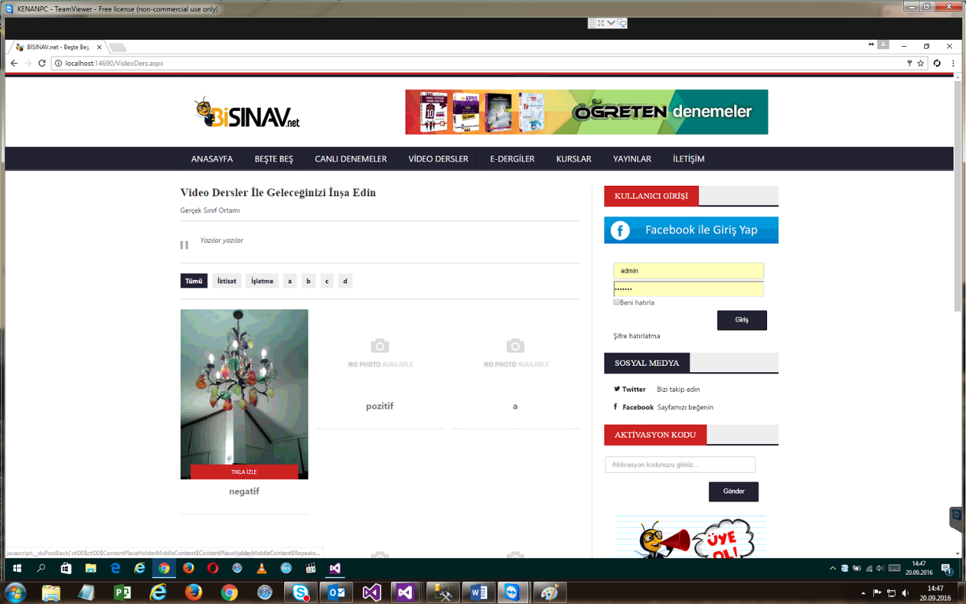

Video page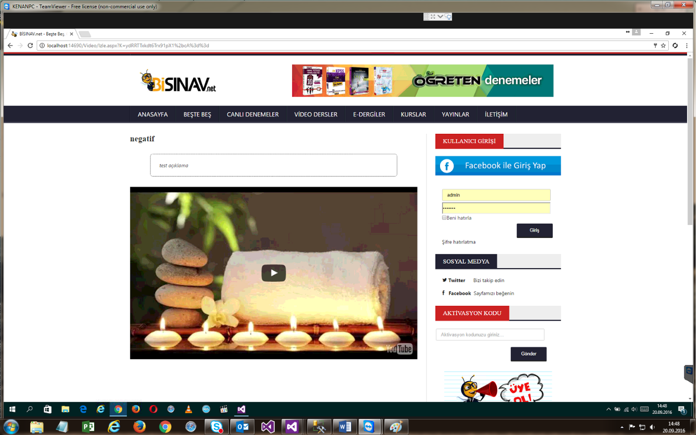

Admin panel login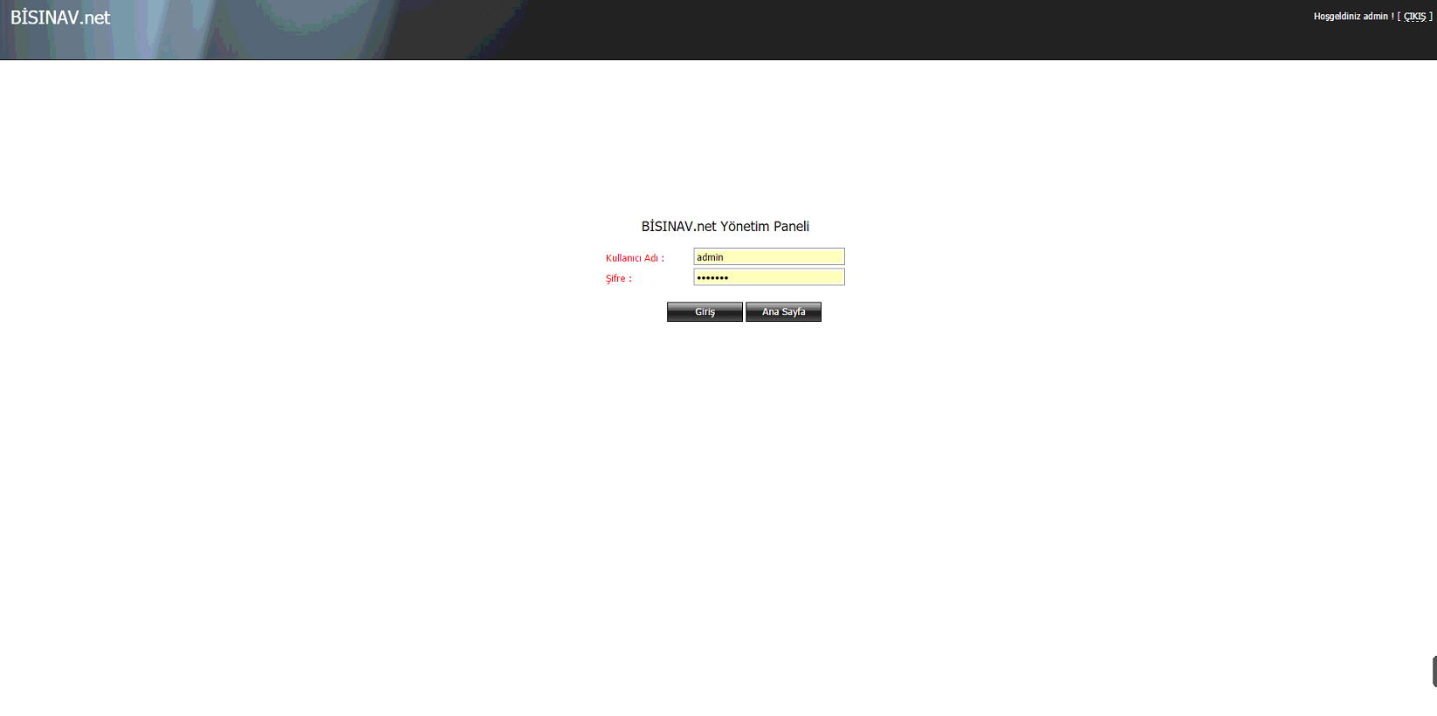

Admin menus and some screens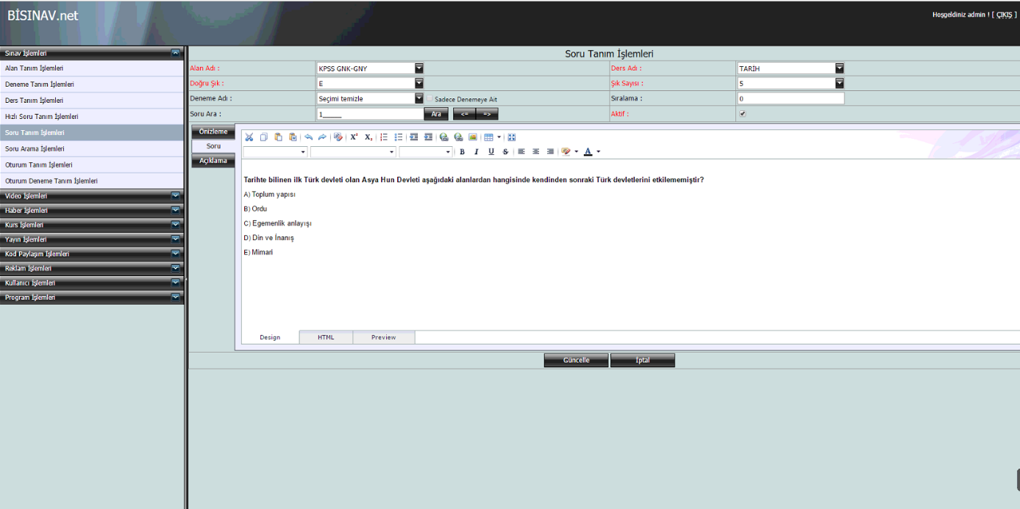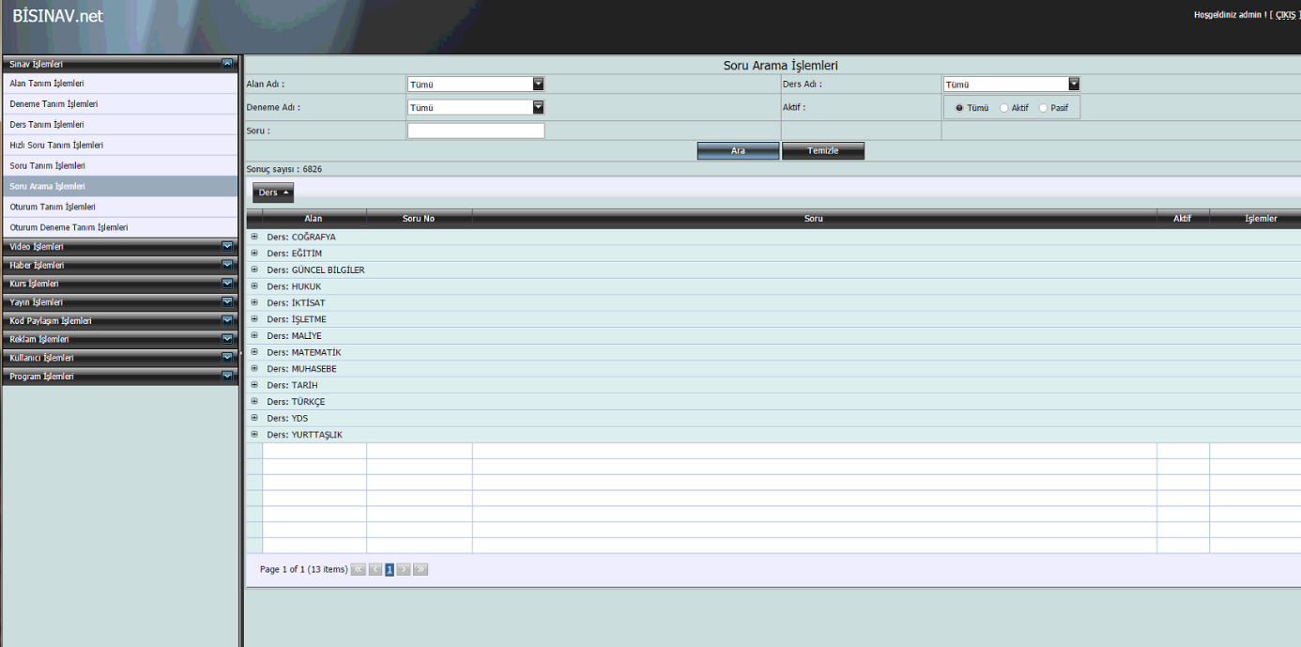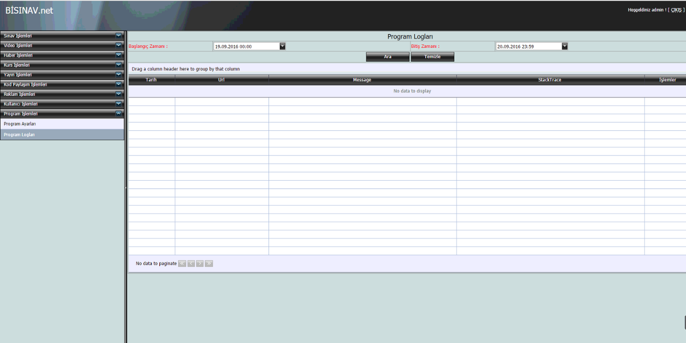

Database Tables

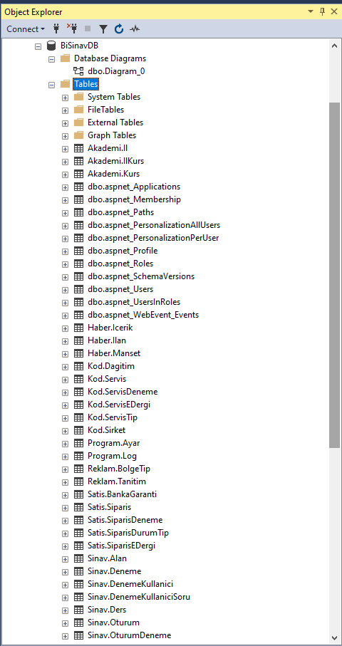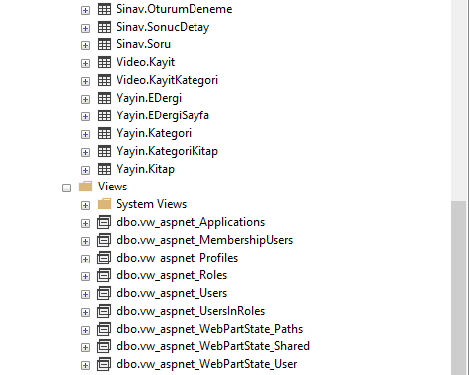

Database Diagram

